**Setting up Python Environments in Rivanna**



**May 2021**

This is documentation on how to set up the virtual environment recommended for working with Python inside Rivanna. This document was created in September 2020 and last updated on May 2020. This is specific to Rivanna, and was originally authored by Martha Czernuszenko ([mc9bn@virginia.edu](mailto:mc9bn@virginia.edu) ), DSPG2020 Fellow. You can direct any questions to Neil Kattampallil ([nak3t@virginia.edu](mailto:nak3t@virginia.edu))

**Part 1: Setting up a virtual conda environment on**

**Rivanna**

**Step 1.1: Open Cluster**

a. Open Rivanna Shell Access from Clusters

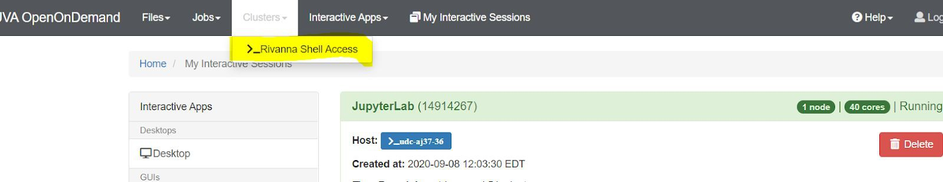

**Step 1.2: Activate conda**

a. Enter *module load anaconda/5.2.0-py3.6*

b. Enter *conda env list* (this is a check and sees which conda environments you have)

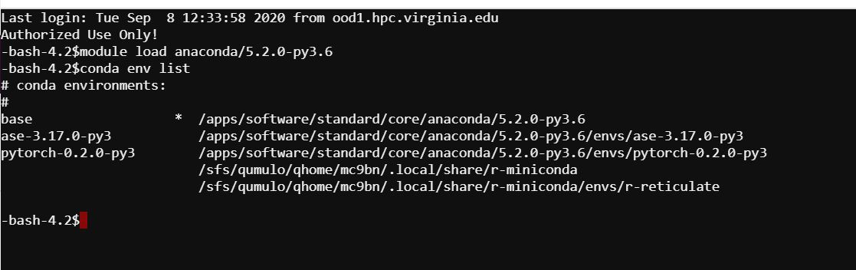

**Step 1.3: Create Virtual Conda Environment by entering:** (do not add a space in your name)

a. Enter *conda create --clone pytorch-0.2.0-py3 --name "Your environment name here"*

Example: **conda create --clone pytorch-0.2.0-py3 --name "martha_bert"**

*This process will take a while, probably 5-10 minutes

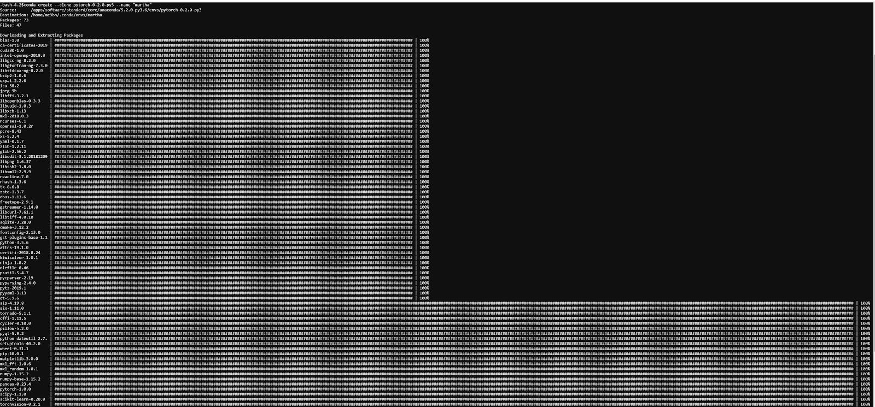

**Step 1.4:**

a. Activate Virtual Environment: Enter *source activate "environmentname"*

Example: source activate "martha"

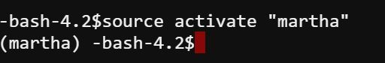

**Step 1.5: Check if your virtual environment has been created:**

a. Enter *conda env list*

(should be in your user id folder)

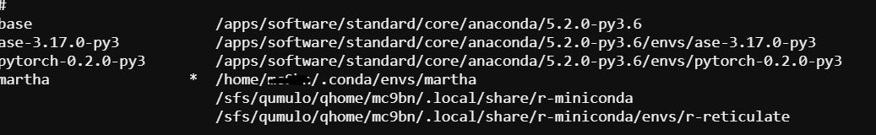

**Step 1.6: Install to switch conda environment via kernel:**

**a.** Enter *conda install nb_conda*

**Step 1.7:** Exit Rivanna Shell Access.

**Part 2:**

**Step 2.1: Launching a Rivanna Session**

(You have to launch a new session or your environment won’t show)

1. Rivanna Partition: BII-GPU

2. Optional: GPI type for GPU partition: NVIDIA P100

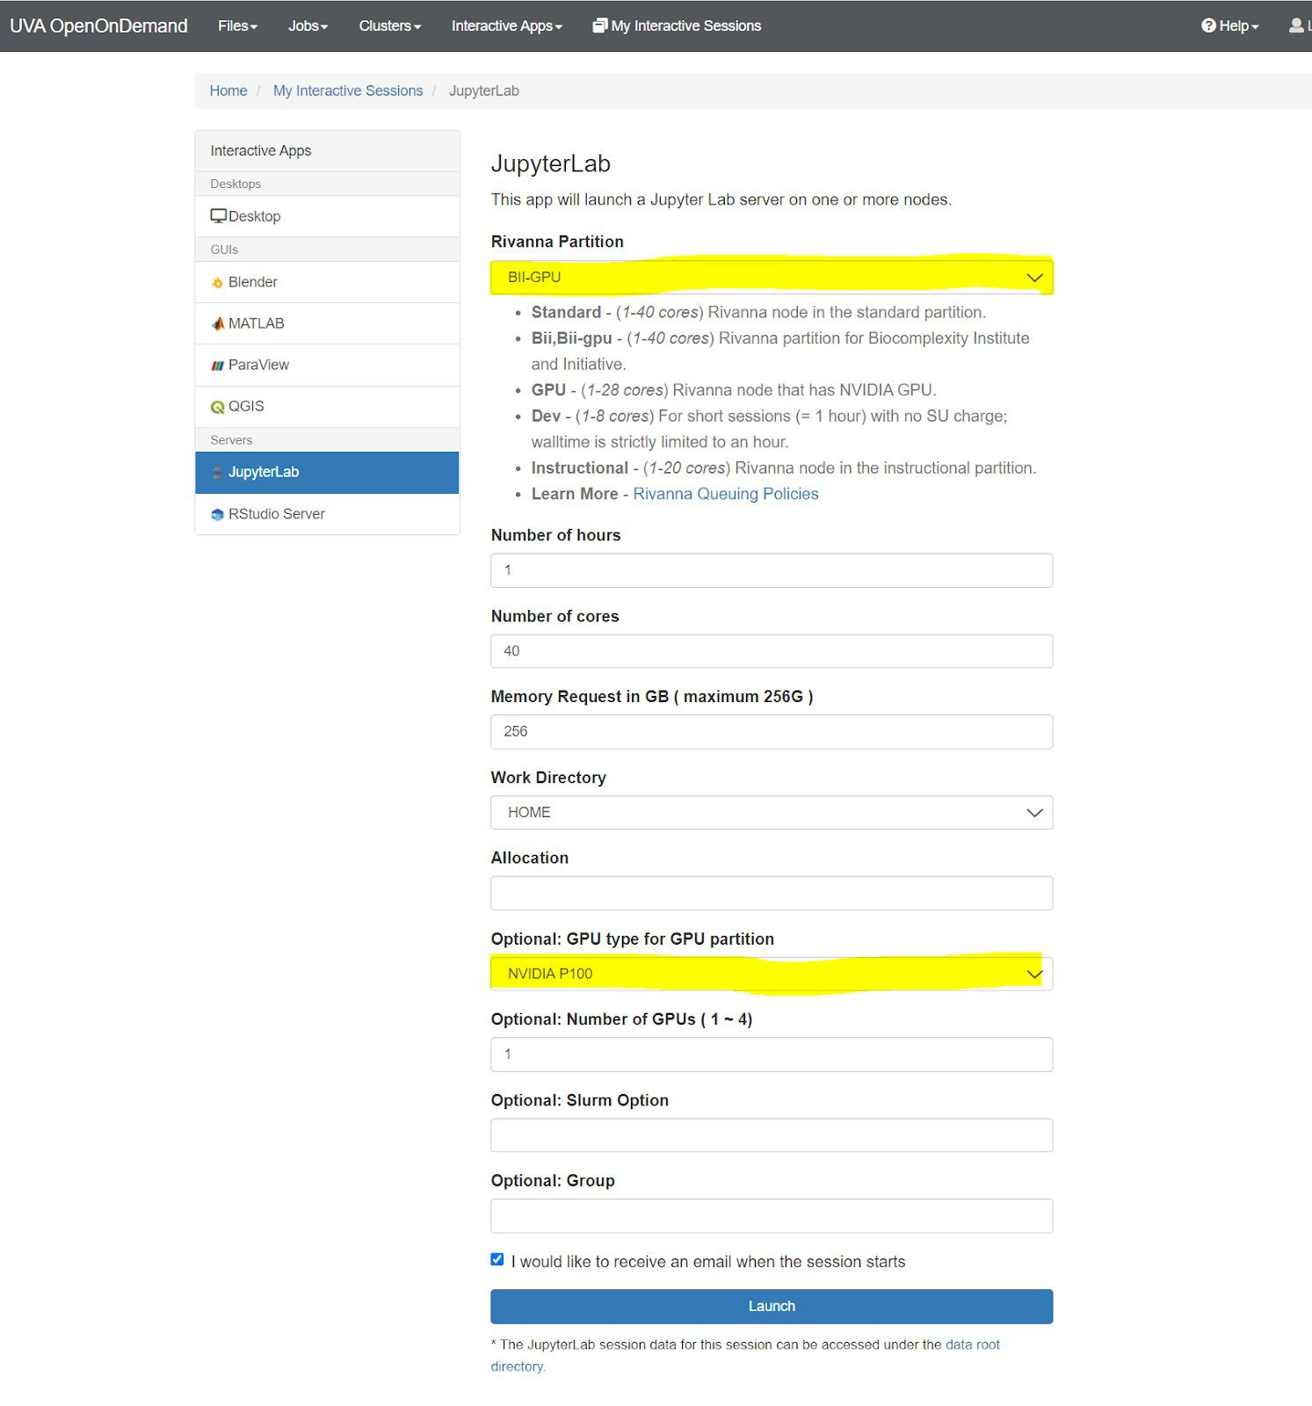

**Step 2.2: Start a new Jupyter Notebook (File > New > Notebook)**

A. Rivanna should prompt you on this message:

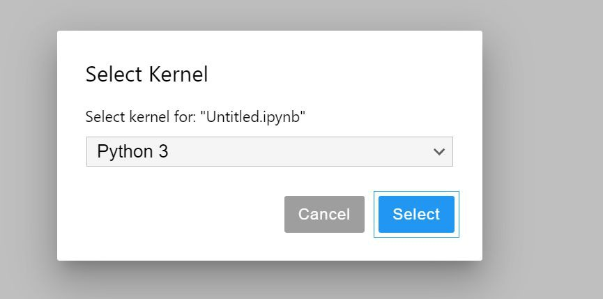

B. Select your environment.

a. If you don’t see your environment here, you need to go back to shell access and take these steps:

i. *module load anaconda/5.2.0-py3.6*

ii. *conda env list*

Do you see your environment?

a. Yes! (This means your environment was created, but you need to enter *conda install nb_conda* to see your environment

b. No? Go back to step 1.1

